- Speaking at the UK Treasury Select Committee this week, members of the Monetary Policy Committee largely confirmed our priors about whether they think the recent weakness in UK activity was mainly demand- or supply-driven. We think the 'cut-hold' approach to loosening policy is likely to continue in the near-term.
- Megan Greene and Huw Pill are the most concerned about supply weakness, but still seem to favour gradual rate cuts. Alan Taylor remains more concerned about demand, while Governor Andrew Bailey appears to be somewhere in the middle. Meanwhile, Catherine Mann expanded on her recent volte-face and seems likely to vote for further cuts.
With four members of the Bank of England's Monetary Policy Committee appearing before the Treasury Select Committee and another giving a speech, this week provided an opportunity to gain further insight into the range of views on the committee. The minutes from February's MPC meeting centred on a debate over whether the recent weakness in activity and employment primarily reflected soft demand or constrained supply. The former implies that slack is emerging in the economy, which will weigh on inflation. In contrast, the latter argues that weak potential output means there's little spare capacity in the economy, risking more structural persistence in wage- and price-setting.
Weighing in on this debate at the TSC hearing, BoE chief economist Huw Pill remarked that the "continued weakness in productivity growth and wider disruptions to the economy's supply-side were perpetuating the persistence of price and wage developments". Meanwhile, external MPC member Megan Greene argued that the recent uptick in measures of private sector earnings growth, food price inflation, and core goods prices were indicative of an economy that is primarily supply-constrained.
These views were similar to those that we had already ascribed to Pill and Greene. They will likely view the results of February's BoE's Decision Maker Panel as backing their narrative. The survey reported rising price expectations and limited recent progress on the forward-looking picture for wages (Chart 1).
Chart 1: February's DMP survey reported a further increase in expected inflation
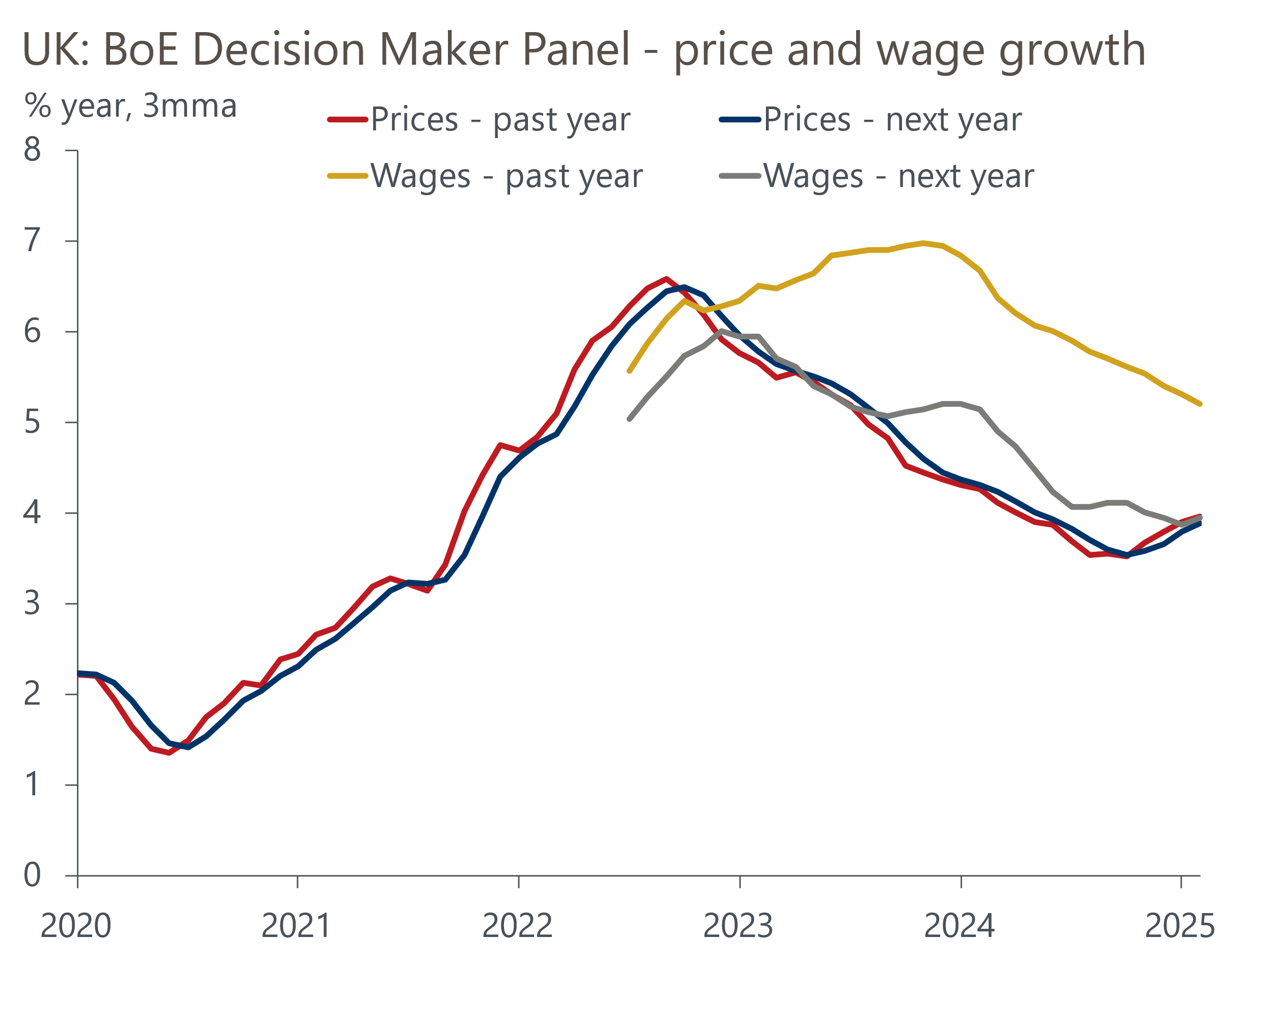
Source: Bank of England Decision Maker Panel

In contrast, Governor Andrew Bailey took a more sanguine view, emphasising that the underlying path for inflation was still downwards. He also played down some of the risks associated with rising headline inflation given the economy's "weakening pattern", with the Governor noting that "the demand weakness argument may be getting a bit stronger relative to last year".
Professor Alan Taylor was more forthright, arguing that the fall in inflation last year occurring alongside a slowdown in activity was "first-order evidence that the shock to demand was dominating". He also remarked that he saw slack appearing in the labour market and that the output gap would be bigger than had been projected in February's Monetary Policy Report forecast.
February's final S&P Global surveys failed to provide much clarity on the activity front. The surveys continued to point to a very meagre pace of output growth at the start of 2025, with the composite PMI edging down to 50.5 from 50.6 in January (Chart 2). But December's strong GDP reading and robust retail sales in January will provide a solid launch pad, and we expect quarterly GDP growth in Q1 to come in much stronger than the pace implied by the S&P Global survey.
Chart 2: The composite PMI has remained relatively soft in recent months
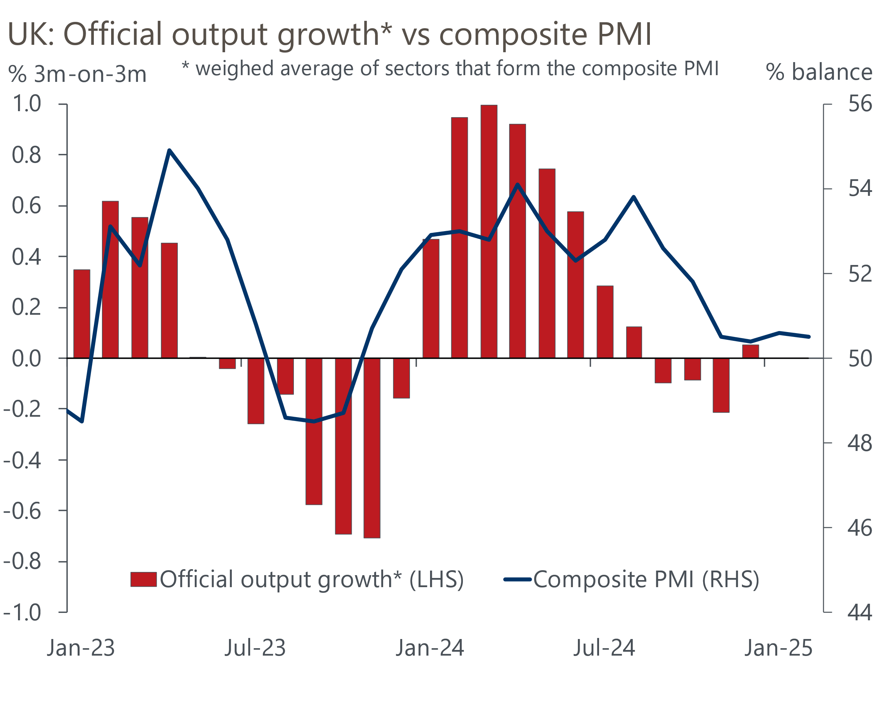
Sources: ONS, S&P Global
Meanwhile, external MPC member Catherine Mann expanded on her surprise decision to vote for a 50bps rate cut at February's meeting in a speech at the Reserve Bank of New Zealand. She put forward the case that "survey evidence from the BoE's DMP on labour demand points to a non-linear downward adjustment as firms address the multi-year accumulation of increased labour costs". This is a risk that we highlighted in a recent note. Against a backdrop of weak labour demand and consumption, she judged that firms are "more likely to have to absorb the inflation hump rather than pass it through" to consumers.
This week's MPC comments largely confirmed our priors on where each member stands on the supply-demand debate. Pill and Greene appear to be more concerned about the economy's supply side than other members, though they see this view as being consistent with a slow pace of rate cuts rather than keeping Bank Rate on hold. Mann will almost certainly vote for another cut on March 20. Though he didn't vote for a 50bps cut in February, Taylor's comments clearly put him in the more dovish demand camp. Bailey is in the middle, and Dave Ramsden's recent speech suggested he's also now on the middle ground, having previously aligned more with Taylor's views. Though the increasing role of supply concerns in policy discussions means the risks around our Bank Rate forecast are more two-sided than a few months ago, the 'cut-hold' tempo looks likely to continue in the near-term.
Stepping away from the monetary policy debate, the BoE's latest Money and Credit release reported a modest fall in mortgage approvals in January. But this was likely driven by a fading of the temporary boost from buyers looking to complete purchases before March's fall in stamp duty thresholds, rather than a shift in underlying momentum. Once this impact has unwound, we expect approvals will show signs of recovery later this year, particularly if the affordability gap continues to recede.

The week ahead
The only economic release of note next week is the GDP data for January. Following a string of underwhelming outturns, GDP surprised on the upside in December, growing 0.4% m/m. The higher headline reading was driven in part by some unusually strong data at the sectoral level, most notably in manufacturing, professional services, accommodation and food, and arts and recreation sectors. We expect to see some payback in these sectors, so we estimate that GDP fell by 0.1% m/m in January. However, given retail sales rose sharply during the month and the Office for National Statistics appears to be battling with a residual seasonality problem, a wide range of outcomes is possible.
Table 1: Week ahead calendar
Date | Events | Period | Measure | Unit | Previous | Forecast
Mar 14 | GDP | Jan | m/m | % | 0.4 | -0.1
Mar 14 | GDP | Jan | 3m/3m | % | 0.1 | 0.2
Mar 14 | Index of services | Jan | m/m | % | 0.4 | -0.1
Mar 14 | Index of services | Jan | 3m/3m | % | 0.2 | 0.3
Mar 14 | Manufacturing output | Jan | m/m | % | 0.6 | -0.3
Mar 14 | Manufacturing output | Jan | y/y | % | -1.4 | -0.7
Mar 14 | Industrial production | Jan | m/m | % | 0.5 | -0.1
Mar 14 | Industrial production | Jan | y/y | % | -1.9 | -0.7
Mar 14 | Construction output | Jan | m/m | % | -0.2 | 0.1
Mar 14 | Construction output | Jan | y/y | % | 1.6 | 0.5
Mar 14 | UK trade | Jan | Trade balance | £bn | -2.8 | -0.3
Mar 14 | UK trade | Jan | Visible balance | £bn | -17.4 | -15.1
Source: Oxford Economics

Key forecasts
Table 2: UK forecast overview
(Annual percentage changes unless specified)
 | 2022 | 2023 | 2024 | 2025 | 2026 | 2027
GDP | 4.8 | 0.4 | 0.9 | 1.0 | 1.5 | 1.7
Private consumption | 7.3 | 0.4 | 0.7 | 1.3 | 1.4 | 1.5
Fixed investment | 5.1 | 0.3 | 1.3 | 0.1 | 3.2 | 2.5
Government consumption | 0.6 | 1.0 | 2.0 | 2.4 | 1.6 | 1.6
Exports of goods and services | 12.6 | -3.2 | -2.2 | -1.5 | 1.2 | 1.5
Imports of goods and services | 13.0 | -4.5 | 1.6 | 0.0 | 1.6 | 1.3
Industrial Production | -6.4 | -0.9 | -1.7 | -0.5 | 0.9 | 1.1
Consumer prices | 9.1 | 7.3 | 2.5 | 3.2 | 2.7 | 2.1
Unemployment rate (%) | 3.8 | 4.1 | 4.3 | 4.5 | 4.5 | 4.3
Current a/c balance (% of GDP) | -2.2 | -2.2 | -2.8 | -2.9 | -2.8 | -2.6
Government balance (% of GDP) | 4.1 | 5.2 | 4.9 | 3.1 | 2.8 | 2.1
Central bank policy rate (%, EOP) | 3.50 | 5.25 | 4.75 | 3.75 | 3.00 | 2.50
10yr govt. bond yield (%, EOP) | 3.67 | 3.54 | 4.57 | 4.41 | 3.91 | 3.45
Exchange rate (US$ per £, EOP) | 1.20 | 1.27 | 1.25 | 1.22 | 1.24 | 1.25
Exchange rate (euro per £, EOP) | 1.13 | 1.15 | 1.21 | 1.21 | 1.21 | 1.21
Source: Oxford Economics
Table 3: Quarterly forecasts for the UK
 | 2024 |  |  |  | 2025
 | Q1 | Q2 | Q3 | Q4 | Q1 | Q2 | Q3 | Q4
GDP (% year) | 0.5 | 0.9 | 1.0 | 1.4 | 0.8 | 0.7 | 1.1 | 1.4
CPI inflation (% year) | 3.5 | 2.1 | 2.1 | 2.5 | 2.8 | 3.2 | 3.6 | 3.4
Bank Rate (%, EOP) | 5.25 | 5.25 | 5.00 | 4.75 | 4.50 | 4.25 | 4.00 | 3.75
10yr gilt yield (%, EOP) | 3.95 | 4.17 | 4.00 | 4.57 | 4.57 | 4.57 | 4.50 | 4.41
US$ per £ (EOP) | 1.26 | 1.26 | 1.34 | 1.25 | 1.24 | 1.22 | 1.22 | 1.22
Euro per £ (EOP) | 1.17 | 1.18 | 1.20 | 1.21 | 1.20 | 1.21 | 1.21 | 1.21
Source: Oxford Economics

Latest Country Economic Forecast:
February 20, 2025

Recent publications

Data Insights
Q1 growth likely stronger than PMI suggests
Manufacturing PMI falls further into contractionary territory
Mortgage demand softened slightly at the start of 2025
PMI too pessimistic on Q1 growth performance
Retail sales soared in January, but seasonality likely played a role

Research Briefings
Four reasons why inflation will be well above target in 2025
Defence spending could still pose a fiscal challenge
What the rise in NICs means for the labour market
Two fiscal wild cards in the Spring Forecast
The UK's fiscal adjustment is at risk of failure

Contacts

Oxford Economics' UK team
- Andrew Goodwin - Chief UK Economist - agoodwin@oxfordeconomics.com
- Edward Allenby - UK Economist - eallenby@oxfordeconomics.com

